### **CLOUD COMPUTING AND GRID SYSTEMS – (SEMESTER IV)**

**TOTAL MARKS: 50 | DURATION: 2 HOURS**

### **PART A (7 x 2 = 14 Marks)**

1. **List the applications of grid computing. (reference ya mwalimu**

Grid computing refer to a form of distributed computing where multiple computers, often geographically dispersed, are connected and work together to solve a single, large-scale problem.

* High-energy physics simulations (e.g., CERN)
* Climate/weather modeling
* Genome sequencing and biomedical research
* Financial market simulations
* Engineering design and analysis (e.g., fluid dynamics)

1. **Mention any four Middleware resource managers. ( reference mwalimu page 15 unit 1)**

What is middleware?

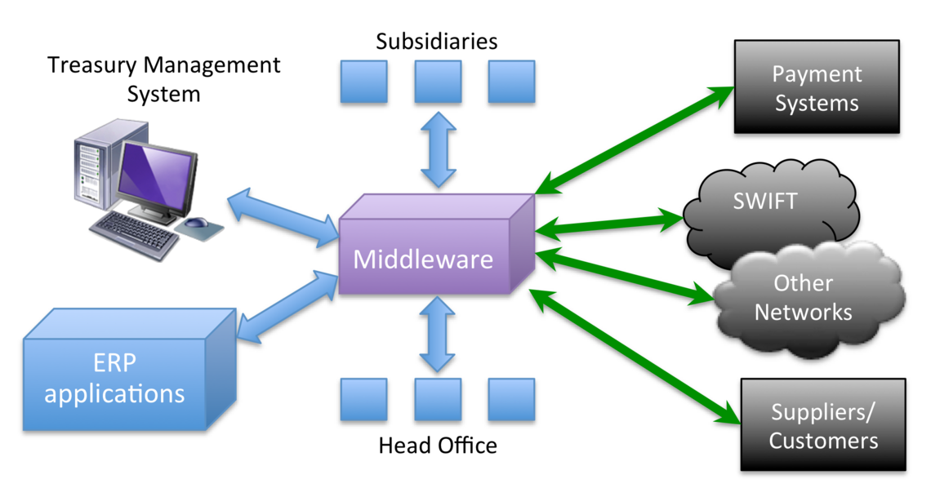

* Globus Toolkit
* UNICORE (Uniform Interface to Computing Resources)
* gLite
* ARC (Advanced Resource Connector)

1. **Explain the importance of layered grid architecture.**

Layered grid architecture simplifies **design, integration, and management** by dividing responsibilities into logical layers:

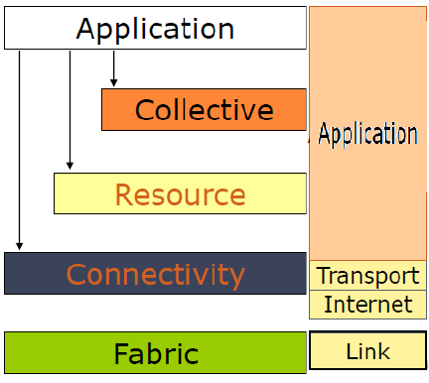

1. **Fabric Layer:** Physical resources (CPU, memory, storage)
2. **Connectivity Layer:** Communication protocols
3. **Resource Layer:** Resource allocation & discovery
4. **Collective Layer:** Coordinates multiple resources
5. **Application Layer:** User-facing applications

This structure improves **interoperability**, **scalability**, and **maintenance**.

**4. Mention the application of Kubernetes?** Kubernetes is used to **automate deployment, scaling, and management** of containerized applications.

* Manages clusters of containers (Docker, etc.)
* Ensures fault tolerance and load balancing
* Enables rolling updates and rollback

**5. Name the categories of specific cloud provisioning.**

* **User self-service provisioning**
* **Advanced provisioning**
* **Dynamic provisioning**
* **Policy-based provisioning**

1. **List the actors and roles of a cloud ecosystem.**

A cloud ecosystem refers to the interconnected network of cloud computing services, solutions, technologies, and providers that enable the delivery, management, and consumption of cloud resources.

* **Cloud Provider:** Supplies infrastructure/services
* **Cloud Consumer:** Uses cloud services
* **Cloud Broker:** Manages service use across providers
* **Cloud Auditor:** Evaluates compliance/security
* **Cloud Carrier:** Network connectivity provider

**7. What are the major design goals of cloud architecture?**

* Scalability
* Availability and Reliability
* Security and Compliance
* Flexibility and Modularity
* Cost Optimization
* Multi-tenancy Support

### **PART B (3 x 4 = 12 Marks)**

**8(a). Expound the Layered Grid Architecture.** ( reference mwalimu 47 unit 1 )

A layered grid architecture breaks the system into modular components:

1. **Fabric Layer:** Raw hardware – computers, storage
2. **Connectivity Layer:** Ensures secure communication (SSL, GSI)
3. **Resource Layer:** Manages and allocates resources (CPU, I/O)
4. **Collective Layer:** Coordinates global resource use across grids
5. **Application Layer:** User programs interact with the grid

Clear separation of concerns improves interoperability.

**OR**

**8(b). List any four comparisons between computational and data grids with an example. ( reference mwalimu page 20 )**

**Types of Grids**

Computational Grid: Focuses on sharing processing power.

Data Grid: Emphasizes sharing and managing large sets of distributed data.

Collaboration Grid: Enables scientists or researchers across different locations to collaborate on a project, pooling their resources and expertise.

| Feature | Computational Grid | Data Grid |
| --- | --- | --- |
| Purpose | High-performance computing | Distributed data access/storage |
| Example | Protein folding simulation | astronomical observations. |
| Data Priority | Temporary, task-specific | Persistent and reusable |
| Tools | MPI, Globus | SRB, GridFTP |

**9(a). Explain briefly about the NIST characteristics of cloud computing?** According to NIST (National Institute of Standards and Technology), the five essential characteristics of cloud are:

1. **On-Demand Self-Service**
2. **Broad Network Access**
3. **Resource Pooling** (shared via multitenancy)
4. **Rapid Elasticity** (scale up/down quickly)
5. **Measured Service** (metered billing & pay as you go)

**OR**

**9(b). Discuss the key technologies that are fundamental to network-based systems.**

* **Virtualization:** Creation of virtual version of computing from a single physical machine
* **Networking Protocols** ( TCP/IP )
* **Networking Devices ( Routers**
* **Middleware:** Facilitates resource abstraction
* **Wireless Technologies**

**10(a). Mention any four examples of SAAS & PAAS service models.**

**SaaS (Software as a Service):**

* Gmail
* Google Docs
* Google drive
* OsIM

**PaaS (Platform as a Service):**

* Google App Engine
* Heroku
* Microsoft Azure App Services
* Red Hat OpenShift

**OR**

**10(b). Write about the design challenges of cloud computing.**

* **Security and Privacy**: Protect data in multitenant environments
* **Latency**: Real-time performance in distributed systems
* **Interoperability**: Vendor lock-in and system integration
* **Data Management**: Huge volume across regions
* **Resource Allocation**: Elastic scaling without overprovisioning

### **PART C (2 x 12 = 24 Marks)**

**11(a). Create a virtual organization as “Cloud Computing” and explain their concepts, working and advantages.**

A **virtual organization** in cloud is a dynamic group of users/services collaborating across organizational boundaries using cloud infrastructure for shared common goal.

**Concept:**

* Users from different geographies collaborate on shared cloud services.

**Working:**

* Resources are provisioned via cloud APIs
* Identity & access managed using IAM tools
* Services are deployed in multi-region VMs or containers

**Advantages:**

* Fast deployment & scalability
* Cost-effective collaboration
* Platform independence

**OR**

**11(b). Discuss the working of Grid Computing in detail.** Grid computing connects geographically distributed resources to solve large-scale problems.

**How it works:**

* Breaks complex tasks into smaller chunks
* Distributes jobs to idle computers in the grid
* Middleware (like Globus) manages job scheduling, communication, and data

**Applications:**

* Scientific research (climate, physics)
* Data-intensive simulations (earthquake modeling)

**Key Benefit:** Harnesses **idle computing power** from many sources.

**12(a). Select any one cloud entity/stakeholder you like to perform among the NIST reference architecture in future? Discuss and defend the scenario with examples.**

**Chosen Role:** Cloud Auditor

**Why:**

* Ensures **security**, **privacy**, and **compliance** in cloud use
* Vital for financial, healthcare, and government sectors

**Example:**

* Auditing AWS/GCP infrastructure to ensure **HIPAA** compliance for a hospital
* Verifying GDPR compliance of European SaaS companies

**Skills Required:**

* Knowledge of cloud platforms (AWS, Azure)
* Familiarity with standards like ISO 27001, NIST 800-53

**OR**

**12(b). Explain the concept of generic cloud architecture and cloud-enabling technologies in hardware, software, and networking.**

**Generic Cloud Architecture Includes:**

* **Infrastructure Layer:** Hardware (servers, storage, networking)
* **Platform Layer:** OS, runtime, middleware
* **Application Layer:** SaaS, APIs, services
* **Collective layer**
* **Communication Layer**

**Cloud-Enabling Technologies:**

* **Hardware:** Multi-core processors, SSDs, network switches
* **Software:** Virtualization tools (VMware, KVM), Containers (Docker)
* **Networking:** SDN (Software-Defined Networking), VPNs, high-speed interconnects

### **ELCS 0003 – GRID & CLOUD COMPUTING (JUNE 2025)**

**DEGREE CONTINUOUS ASSESSMENT TEST – II | YEAR: III | TOTAL MARKS: 50**

### **PART A (7 x 2 = 14 Marks)**

**1. Write about federation clouds.**

Federated clouds are a **collaborative network of cloud providers** that interoperate to provide resource sharing, load balancing, and service integration. Users benefit from cross-provider data migration, SLA enforcement, and seamless service access.

**2. Discuss the cloud that Netflix is utilizing?**

Netflix utilizes **Amazon Web Services (AWS)** to stream millions of hours of video content daily. AWS provides Netflix with:

* Global scalability (via AWS regions and edge locations)
* Reliability with EC2( for computer), S3(storage), Lambda, DynamoDB
* Auto-scaling and performance monitoring (CloudWatch(observation)

1. **What are the Hadoop YARN and Hadoop common?( reference page 26 )**

The Hadoop ecosystem is a collection of open-source tools and frameworks built around the core Apache Hadoop project, designed for storing and processing vast amounts of data across distributed computer clusters.

* **Hadoop Common:** Set of shared utilities and libraries used by other Hadoop modules.
* **Hadoop YARN (Yet Another Resource Negotiator):** Responsible for resource management and job scheduling within Hadoop clusters.

**4. Provide a description of the level of abstraction.**  
Levels of abstraction hide the complexity of lower-level operations. In cloud computing:

* **Hardware abstraction**: Virtualization (e.g., VMs, containers)
* **Platform abstraction**: PaaS hides OS/runtime from developers
* **Service abstraction**: Users interact with APIs, not raw infrastructure

**5. Discuss about the CloudSim framework. ( reference ya mwalimu page 64 unit 4 )**  
CloudSim is a **simulation toolkit** for modeling and testing cloud environments. It allows researchers to:

* Simulate VM provisioning, task scheduling, and data center behavior
* Test energy efficiency, network latency, and SLA violations
* Prototype new cloud algorithms before real deployment

1. **Draw the structure of security architecture.**  
   The structure typically includes:

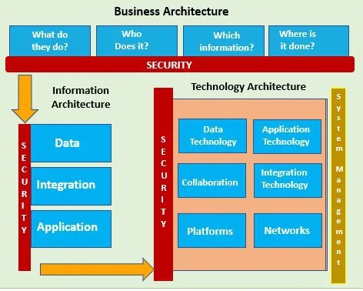

* **Identity & Access Management (IAM)**
* **Data Protection & Encryption**
* **Network Security (firewalls, intrusion detection)**
* **Application Security (patching, code review)**
* **Monitoring & Auditing Tools**

**7. Define least privilege principle. ( reference ya mwalimu page 50 )**

.

* Is the method of Providing users with only the minimum level of access necessary to perform their job functions, minimizing potential damage in case of a security breach.

### **PART B (3 x 4 = 12 Marks)**

**8(a). Discuss the topologies used in inter-cloud architecture.**  
Topologies describe how different clouds interconnect:

1. **Hybrid Topology:** Combination of private/public cloud with seamless integration (common in enterprises)
2. **Peer to Peer Federation:**
3. 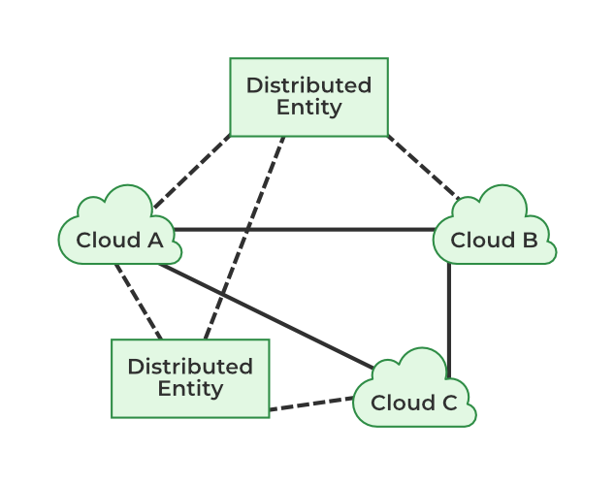

**Centralized**:

1. 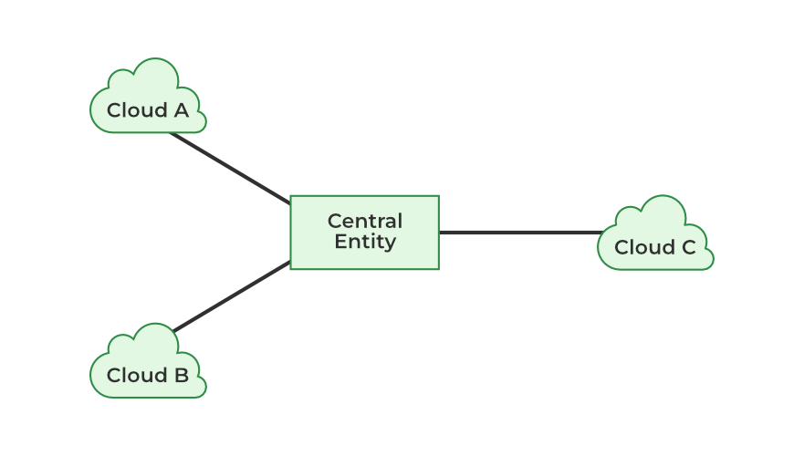
2. **Mult-cloud**:
3. 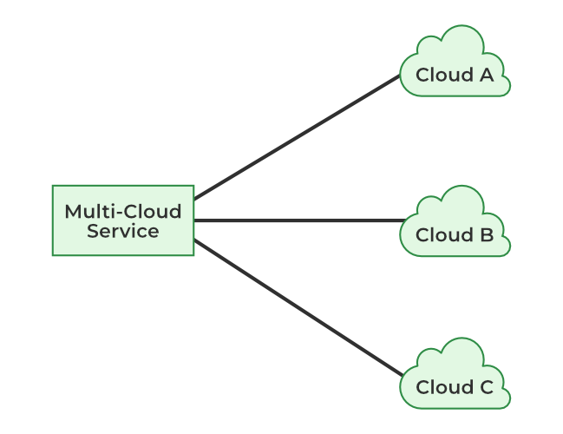

**OR**

**8(b). Differentiate CloudSim and OpenStack platforms.**

| Feature | CloudSim | OpenStack |
| --- | --- | --- |
| Purpose | Simulation Toolkit | Real Cloud OS Platform |
| Deployment | Not deployed – simulated | Real infrastructure environment |
| Use Case | Research/algorithm testing | Actual service provisioning |
| Programming | Java-based toolkit | Python-based cloud suite |

**9(a). Describe the working process of MapReduce model with an example.**

MapReduce is a programming model that uses parallel processing to speed large-scale data processing.  
MapReduce processes large data sets by:

1. **Map Phase:** Divides tasks into key-value pairs (e.g., words in a doc)
2. **Shuffle & Sort Phase:** Groups values by keys
3. **Reduce Phase:** Aggregates or summarizes data

**Example:**

Tokyo Example: 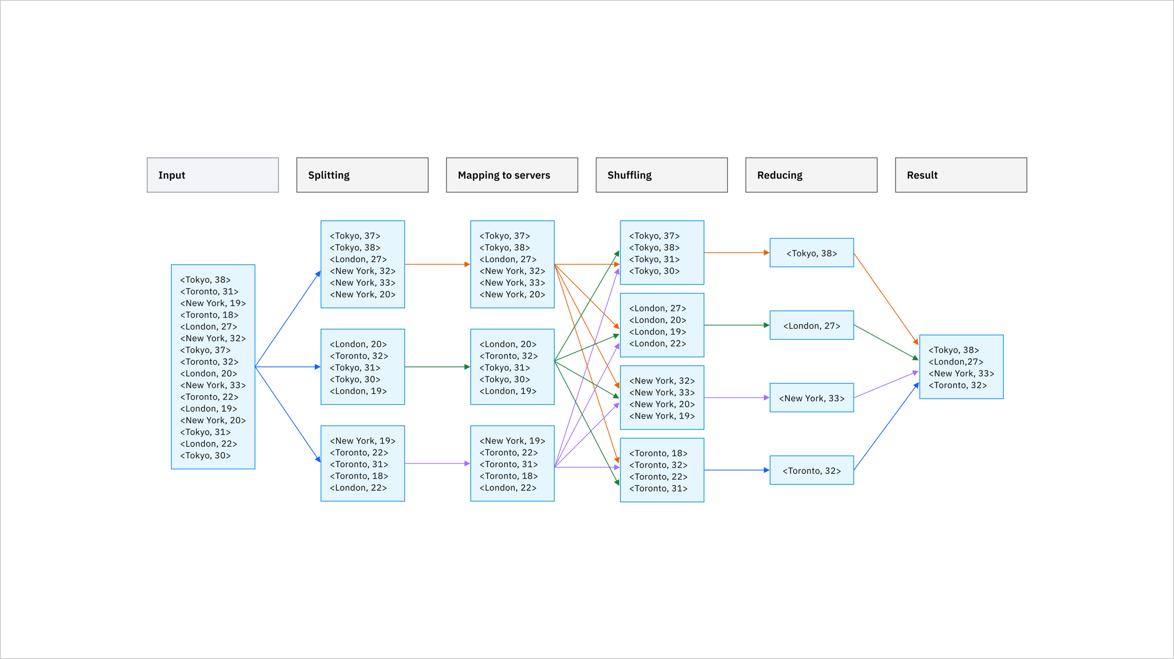

**OR**

**9(b). Explain GAE and AWS in detail.**

* **Google App Engine (GAE):** PaaS that lets developers build and deploy scalable apps on Google infrastructure. Auto-scaling, supports multiple languages (Python, Go, Java).
* **AWS (Amazon Web Services):** IaaS and PaaS offering compute (EC2), storage (S3), databases (RDS, DynamoDB), and AI services. Highly flexible and globally distributed.
* 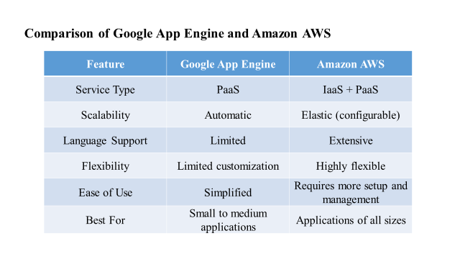

**10(a). Draw the IAM architecture and explain their components.**  
IAM (Identity and Access Management) architecture includes:

1. **Users & Groups** – End-users, roles
2. **Permissions**– JSON-based access rules
3. **Authentication** – Login methods (MFA, SSO)
4. **Authorization** – Determines what a user can access
5. **Audit Logs** – Tracks all identity activity for compliance

**OR**

**10(b). Discuss about VMware ESXi in detail.**  
VMware ESXi is a **type-1 hypervisor** used to run multiple virtual machines on a single server without a host OS.

* Supports VM provisioning, migration (vMotion), and clustering
* Manages CPU, memory, network for each VM
* Backbone for private cloud setups

### **PART C (2 x 12 = 24 Marks)**

**11(a). Discuss the key steps involved in resource provisioning and cloud exchange platforms. (REFERENCE PAGE 33 unIT 3 )**  
**Steps:**

1. **Resource identification** – Identify available resources
2. **Resource Allocation** – Based on policy, pricing, QoS(Quality of Servic)
3. **Confirgutation management** – Provision VMs, containers, storage
4. **Deployment strategy** – Track resource usage
5. **Automatic deployment** – Auto-adjust resources (scale up/down)
6. Monitoring and o**p**timization – Free resources after use
7. Security measures

**Cloud Exchange Platforms:** Allow resource trading between providers and consumers with SLA, dynamic pricing.

**OR**

**11(b). Compare the paradigms of parallel and distributed programming with suitable diagrams.**

| Feature | Parallel Programming | Distributed Programming |
| --- | --- | --- |
| Memory | Shared | Distributed |
| Location | Single machine | Multiple machines |
| Speed | Faster (lower latency) | Slower (network delays) |
| Example Language | CUDA | RPC( remote procedure call ) |

Diagram:

* Parallel → CPUs in same machine
* Distributed → Nodes in a network

**12(a). Discuss about the risk management structure and their importance in detail.**

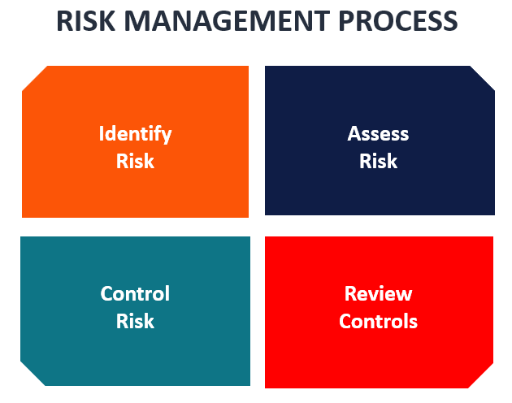

* **Risk Identification** – List possible threats (e.g., data loss)
* **Risk Assessment** – Probability × Impact analysis
* **Mitigation Planning ( control )** – Encryption, backup, firewall
* **Monitoring & Review ( review controls )** – Regular audits, incident response

Importance: Prevent service outages, data breaches, ensure compliance

**OR**

**12(b). Compare the various types and aspects of security with an example.**

| Security Type | Description | Example |
| --- | --- | --- |
| Physical Security | Protect hardware | Biometric locks, env monitors |
| Network Security | Protect data in transition | Firewalls, VPNs |
| Application Security | Prevent code vulnerabilities | Input validation |
| Data Security | Protect data at rest | Encryption, access control |
| Identity and access management ( IAM) Security | Ensure user authenticity | IAM, MFA |

Aspects involve implementing controls like encryption, firewalls, intrusion detection systems, and regular security assessments to mitigate risks and ensure business continuity.